Handout no.

|  |  |
| --- | --- |
| **Name** | Ahmad Hassan, Faizan, Asad |
| **Reg. No** | 2019-EE-373,381,383 |
| **Marks/Grade** |  |

**EXPERIMENT NO. 9**

**Perform reduction of busses in main power system to reduce system for understanding and calculation.**

**Objective:**

At the end of this lab session students will be able

* To accurately select and reduces the buses that are not useful and make system more compact for better calculations.

**Introduction:**

Reduce System for Understanding and Calculation in PWS Model. In this lab, you will learn how to simplify a large power system model by reducing the number of buses in the system. This simplification technique is useful for performing power flow analysis and other calculations on large power systems. The lab manual is divided into several sections that will guide you through the process of reducing the buses in a power system. First, you will learn about the concept of bus reduction and its benefits. Then, you will be introduced to the PWS (Power World Simulator) software, which will be used to perform the bus reduction. You will also learn how to import a power system model into PWS and prepare it for bus reduction. Next, you will learn how to perform the actual bus reduction using PWS. This will involve identifying the buses to be reduced, selecting the reduction method, and adjusting the reduction parameters. You will also learn how to validate the reduced model and compare it to the original model. Finally, you will learn about the limitations of bus reduction and when it is not appropriate to use this technique. You will also learn about the potential impact of bus reduction on the accuracy of power system analysis results. Throughout the lab, you will have the opportunity to apply the concepts you learn to a real-world power system model. By the end of the lab, you should have a solid understanding of how to perform bus reduction in PWS and the benefits and limitations of this technique.

**Power System Circuit:**

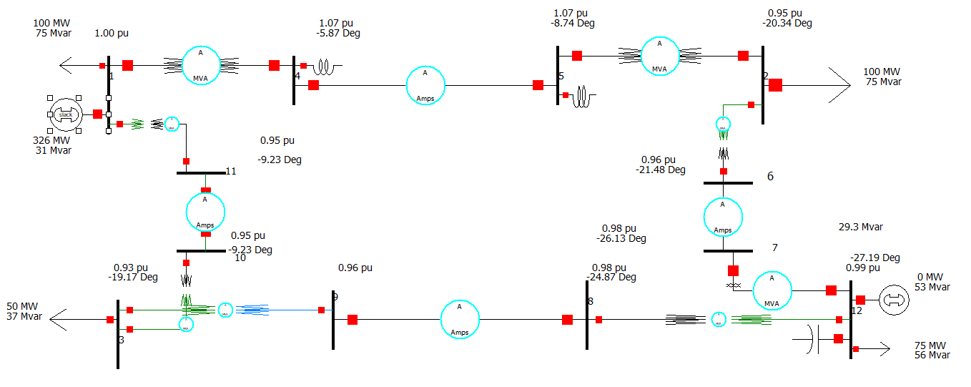**Fig 9.1: Power Word Simulator**

**Setting and results of generator setting:**

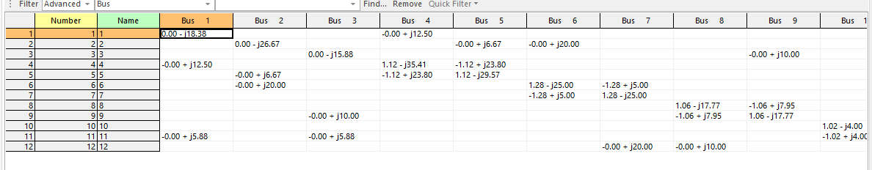

**Fig 9.2: Y-Bus (Before Reducing the Model)**

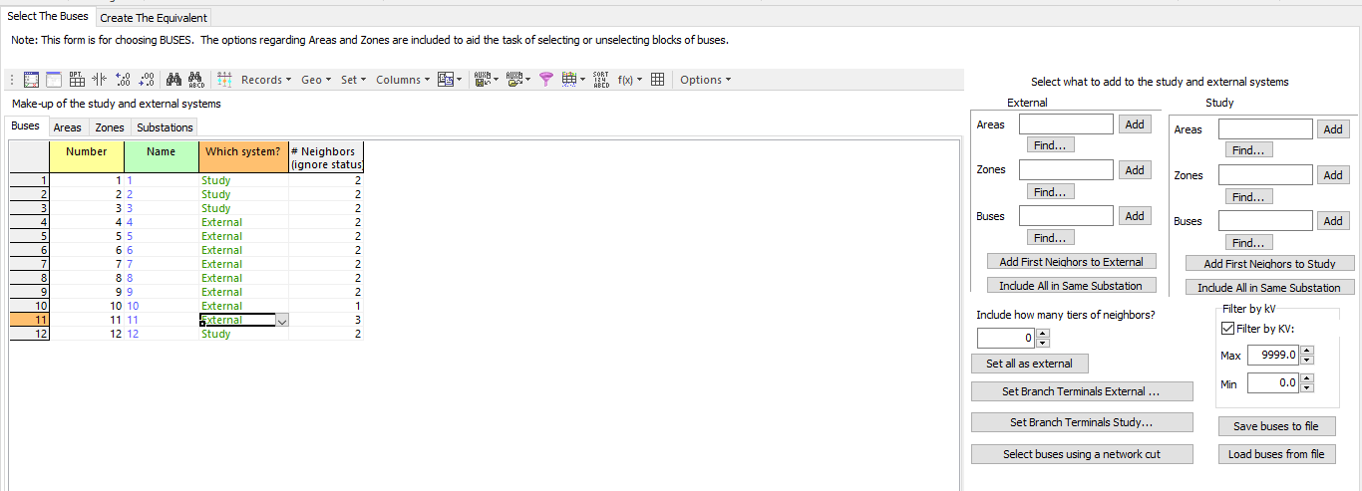

**Fig 9.3: Selection of Buses to be excluded**

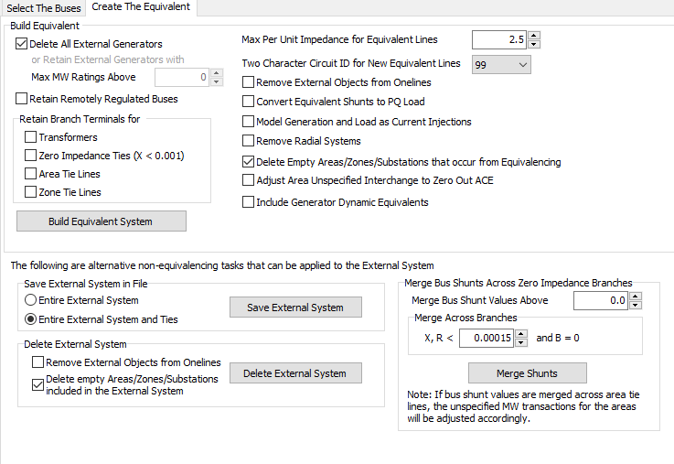

**Fig 9.4: Create the Equivalance circuit**

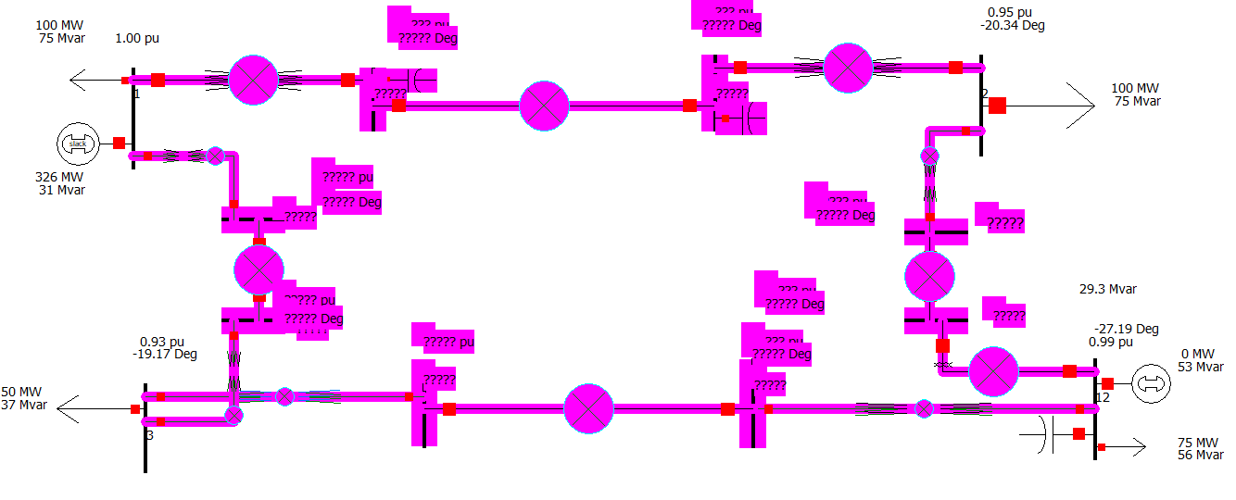**Fig 9.5: Reduced Model in Edit Mode**

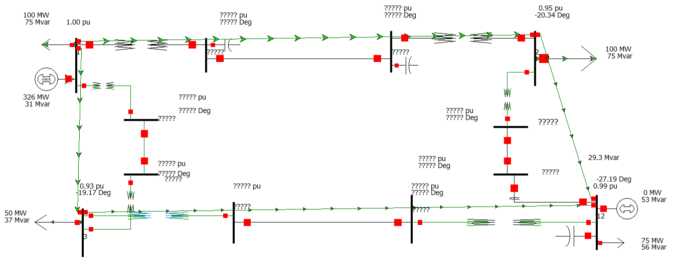**Fig 9.6: Reduced Model in Run Mode**

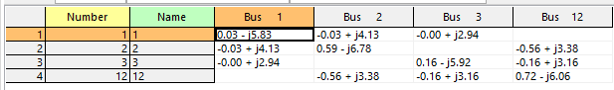**Fig 9.7: Y-Bus (After the reduction of Model)**

**Observation and Conclusion:**

In this lab, we have learned about the reduction of buses in the power system. We use equivalencing method for reducing the buses. Firstly, we done this in 12-bus system and deleted non critical buses. This reduction of buses has provided us easy understanding and simplification of large bus systems. First we identifies the buses to be reduced and selection of given parameters for reduction. Process is done by selecting unnecessary buses in model and excluding them. We auto insert the lines after reduction. By doing this experiment, we came to know that reduction can simplify power system model and easy to perform power flow. Reduction of buses has largerly effect the power system Analysis technique. This lab also give us better understanding of component of power system such as generator, transformer and how to model them using equivalent circuit parameter.